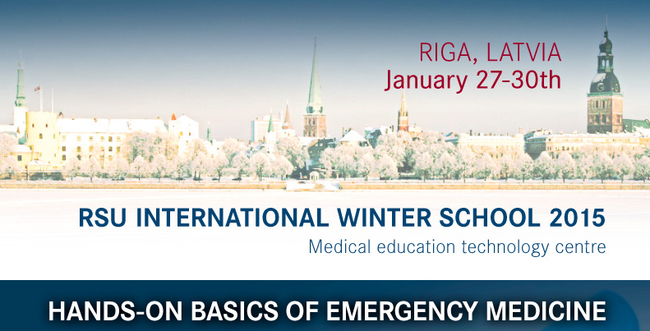
APPLICATION FORM
RSU International Winter School 2015
January 27th-30th 2015

PERSONAL DETAILS

Title (Mr/Miss/Mrs/Ms/Dr): Family/last name:
First name: Gender: Male  Female 
E-mail address: Country:
Home address: Telephone number:

ACADEMIC DETAILS

College/university details:

home college/university:
exact name of degree:
programme:
year of study:
average grade:

EMERGENCY CONTACT DETAILS

Family/last name: First name:
E-mail address: Telephone number:

OTHER DETAILS

When are your arriving:
Have you planned to attend:

Cultural Evening (snack bar): Yes  No 
Visit to Riga Old Town, dinner in the Old Town: Yes  No 
Awards ceremony: Yes  No 

How did you find information about RSU International Winter School 2015?
Is English your first/native language? Yes  No 
Do you have any disabilities or additional educational needs? Yes  No 

ENCLOSED DOCUMENTS

❒ official confirmation of a student status and academic transcript (in English);
❒ personal statement (in English) describing your purpose to attend the International Winter School, as well as what you expect to gain from the course;
❒ proof of English proficiency (a certificate of TOEFL 550/IELTS 6.5, any other relevant certificate or a letter of reference from an academic).

REQUIRED

❒ I confirm that the information disclosed on this application is accurate.

Print name:
Signed:
Date:

This application along with all the requested documents should be submitted till November 25, 2014 to:

Riga Stradins University
Phone: +371 67061581
E-mail: education@rsu.lv
www.rsu.lv/winterschool

