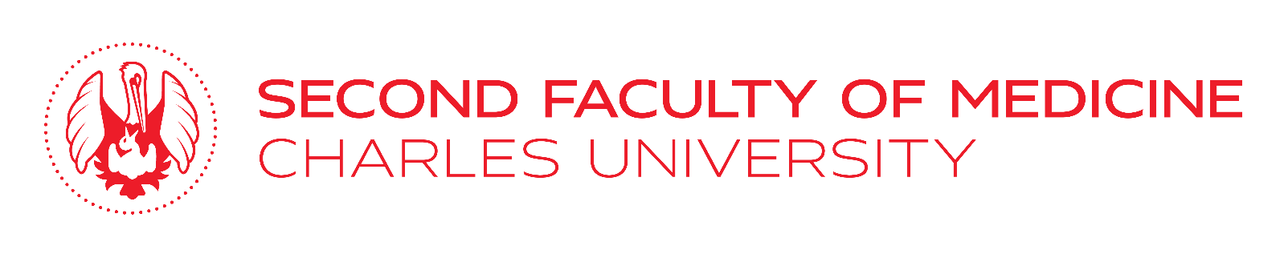
Application – UNICA Student Conference

NOVA University Lisbon, 18 – 21 July 2021

Please, fill in, sign and send to Department of Foreign Affairs, Mrs Pavla Byrne at e-mail: pavla.byrne@lfmotol.cuni.cz. Deadline is 25 February 2021.
Do not forget to attach your motivation letter (max. 1 page of A4).

Surname:
First name (s):
Date of birth:
Nationality:
Email:
Mobile:
Year of study:
Date | Signature

