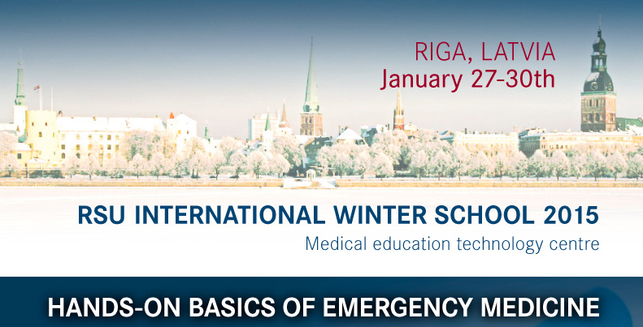

PROGRAMME

Tuesday, January 27, 2015

8.30-9.00 | Registration
9.00-9.30 | Welcome address
9.30-11.00 | Latest CPR Guidelines (adults and children)
11.00-11.30 | Coffee break
11.30-13.00 | CPR Basic Life Support Practice (adults and children)
13.00-14.00 | Lunch
14.00-16.00 | CPR Advanced Life Support Practice (adults and children)
16.00-17.00 | Tour at Riga Stradins University
17.00-21.00 | Cultural Evening (snack bar)
including: latest CPR guidelines on children/adult- basic and advanced life support; practical use of AED- automated external defibrillator; practical management of intra-ossal access during CPR; practice on the latest CPR guidelines both in adults and children.

Wednesday, January 28, 2015

8.30-9.00 | Registration
9.00-10.30 | Airway management, difficult airways and intubation, algorithm
10.30-11.00 | Coffee break
11.00-13.00 | Practice in airway management (normal airways)
13.00-14.00 | Lunch
14.00-16.00 | Practice in airway management (difficult airways)
16.00-21.00 | Visit to Riga Old Town, dinner in the Old Town
including: methods of secure airway providing using different technical equipment; the practical use of oropharyngeal/ nasopharyngeal airways, laryngeal mask, laryngeal tube; practical endotracheal intubation; causes and solutions in the case of difficult airways and difficult intubation.

Thursday, January 29, 2015

8.30-9.00 | Registration
9.00-11.00 | Fluid management, the role of fluids in human body
11.00-11.30 | Coffee break
11.30-13.00 | Scenario-based training and analysis
13.00-14.00 | Lunch
14.00-16.00 | Visit to Intensive Care Unit
17.00-18.00 | Dinner
18.00-22.00 | Free time

including: the distribution of fluids in human body; fluid management in ICU; fluid management during CPR; scenario-based training and analysis of emergency situations; analysis of clinical situations with observations in ICU.

Friday, January 30, 2015

8.30-9.00 | Registration
9.00-10.30 | Scenario-based training and analysis
10.30-12.00 | Visit to Cardiac Intensive Care Unit
12.00-14.00 | Lunch
14.00-16.00 | Visit to the RSU Museum of the Institute of Anatomy and Anthropology
16.00-18.30 | Free time
18.30-21.00 | Awards ceremony

including: scenario-based training and analysis of emergency situations; summarising theoretical and practical knowledge of the training; analysis of clinical situations with observations in CICU.

For more information:
webpage: www.rsu.lv/winterschool
e-mail: education@rsu.lv

