|  |
| --- |
| **Fresher’s Week with Intensive Czech Course** |

The Dean, the Language Department and the Association of International Medical Students (AIMS) of the 2nd Faculty of Medicine cordially invite you to attend an orientation week for 1st year students. The purpose of this week is to help you settle down and provide a smooth transition into your first year at medical school. There is an intensive Czech course available to give you a first glance into the language and life in Prague. In addition, there are afternoon activities planned including tours of the faculty and important departments, discussion forums where you can meet upper year students and get some essential information, as well as student talks with advice on getting through 1st year. Also to look forward to are the evening events like the team-building activites, pub quizzes and nights out where you can meet your peers as well as get the chance to win great prizes like your first muscle poster or stethoscope! The week will end with the White Coat Ceremony, where you will receive your first white coat symbolizing your entrance into the medical society.

**Program at a glance**

|  |  |  |  |  |  |  |
| --- | --- | --- | --- | --- | --- | --- |
|  | **Mon 26. 9.** | **Tue 27. 9.** | **Wed 28. 9.** (state holiday) | **Thu 29. 9.** | **Fri 30. 9.** | **Sat 1. 10.** |
| **8.30** | **Czech**  Meeting point outside the Main Lecture Hall,  Motol Hospital | **Czech**  Dept. of Languages | *10.00*  ***“Lost in Motol” -*Tour part 1** – Find your way around the hospital and important sites on the university campus  Outside the Main Lecture Hall,  Motol Hospital | **Czech**  Dept. of Languages | **Czech**  Dept. of Languages |  |
| **13.00** | **LUNCH** | **LUNCH** | **LUNCH** (Pizza Colosseum) | **LUNCH** | **LUNCH** |  |
| **14.00** | ***Welcome speech*** –Dean of the Faculty  “***Welcome to the Life of a Med Student****”-*  All you need to know about getting started as a 1st year – upper year students  Plzeňská | ***Study / Examination Rules*** *of the 2nd Faculty of Medicine and University website* – Vice Dean  *15.30*  ***Exhibition of textbooks*** *in the University Library*  Plzeňská | ***“Lost in Prague”* - Tour part 2**  – How to get a tram pass, student card, libraries, finding your way through Prague city etc. | *“****Welcome to Czech Republic****”*  A guide through the social and cultural aspects of the country you’ll be living in –Language Department  Plzeňská | *“****Survival of the Fittest****” -* Tips on how to make it successfully through 1st year in Charles University  Q & A Discussion Forum with upper year students  Plzeňská | 18.00  “***White Coat Ceremony***” in Břevnovský klášter including the celebration buffet |
| **20.00** | ***Team building*** in Palanca | ***Pub quiz*** in Red Room | ***Lounging*** at Jet Set, Anděl |  | *Prague by Night* and I*nter-Faculty* ***Medical Mashup party*** at Lavka |  |

The students attending the week will have the opportunity to take part in all activities mentioned above, and will also have the privilege be owners of their very own *University White Coat, as well as the* Czech book “*Basic Czech*”, used throughout the year

* There will also be an option to participate in the White Coat Ceremony only

**Fresher’s Events**

|  |  |  |  |
| --- | --- | --- | --- |
| **C:\Users\Annika\Desktop\Freshers Week 2010\Ajinkya\DSC07183.JPG**  *Enjoyable cooperation at the Team building* | | **TEAM BUILDING** Join us for a fun-filled evening of team building activities, crazy games and chances to win countless magnificent prizes. Student performances will also make the evening one to look forward to!  **PUB QUIZ** Bring your brains to Pub Quiz! Hosted at Red Room, fresher’s pub quiz is a great way to meet up and socialise with your new classmates. With live music including performances from senior students, student bar prices, and of course, fabulous prizes for | |
| the winning team, this promises to be an action packed evening from start to finish. Entry to Red Room, the pub quiz and an entry drink are all included. How smart are you?  **PRAGUE BY NIGHT and MEDICAL MASHUP** For the first time ever 1st, 2nd and 3rd faculty of medicine are teaming up to give you all the best opportunity to meet and greet fellow medical freshers and senior students from all over the world. Hosted at club Lavka on the Vltava river near Charles Bridge, the evening promises great people, great music, and a great atmosphere. Special student discounts on all your favourite drinks will be available throughout the night, so come along and party the night away! | | | *Břevnovský klášter* | |
| *The celebration takes place in the*  *Theresian Hall*    *The deluxe three course buffet will be*  *enjoyed in the candle lit wine cellar* | **WHITE COAT CEREMONY** After a very successful initiation last year, the 2nd Medical Faculty is hosting a White Coat Ceremony for the second time in the history of Charles University. This ceremony represents the first year medical student’s induction into the medical society. Speeches will be given by the Dean and faculty members and individually, each student’s name will be called and you will receive your first university white coat personally from the Dean of the faculty. Along with your peers, you will then recite an oath pledging your sincerity to your future profession.  The White Coat Ceremony will be held in the beautiful and historical monastery called Břevnovský klášter (<http://www.brevnov.cz/index.php>), in an extraordinary ceremonial hall, the Theresian Hall. After the ceremony, everyone is invited to enjoy a luxurious three course buffet dinner in the enchanted cellar of the monastery.  **Family and friends are most welcome to attend and witness this moment of honor.**  * Dress code: formal | | |

**Intensive Czech Course Syllabus**

A very important part of the program is an introduction to the Czech language. The best way to have a smoother transition into a new living environment is to master the language. This will help you to have easier communication with patients, learn more about the country, and more importantly help you to deal with the problems that may arise when living in the Czech Republic. This course offers an excellent opportunity to start learning the Czech language very quickly and intensively. The Czech classes will be held every morning (except Wednesday that is a state holiday) between 8.30 - 9.30, 9.45 - 10.45, 11.00 - 12.00 and 12.10 -13.00 (you can make tea or coffee during your break in the small kitchen available). The syllabus for the week is as follows:

**Monday** The Czech alphabet  
Pronunciation  
Basic phrases and greetings  
Some important phrases and notices  
How are you?

**Tuesday** The verb “to be“  
Where are you from? What? Who?   
Nouns and adjectives  
Gender  
Where is it?   
A Town

**Thursday** Soft and hard adjectives   
What is it like?   
Colours and fruits  
Demonstrative and possessive pronouns

**Friday** Cardinal numerals  
What time is it?   
How much is it?   
The verbs “to have” and “to like”  
Hospital and university – basic vocabulary and phrases

After this course, you will be able to read Czech text, understand basic phrases (How are you? Where are you from? How much does it cost? What time is it?). You will be able to introduce yourselves as well as read and understand basic signs (open, closed, entrance, tickets, out of order, etc.). You will also know Czech words for some food, drinks and furniture (water, wine, bread, chair, etc.).

**“Basic Czech” - the book which is used in the Czech curriculum of the 1st year is included**

*What better way is there to get settled down in a new country and university than to meet the students who have successfully done it before you? We hope to see you there!*

**How to find our Faculty**

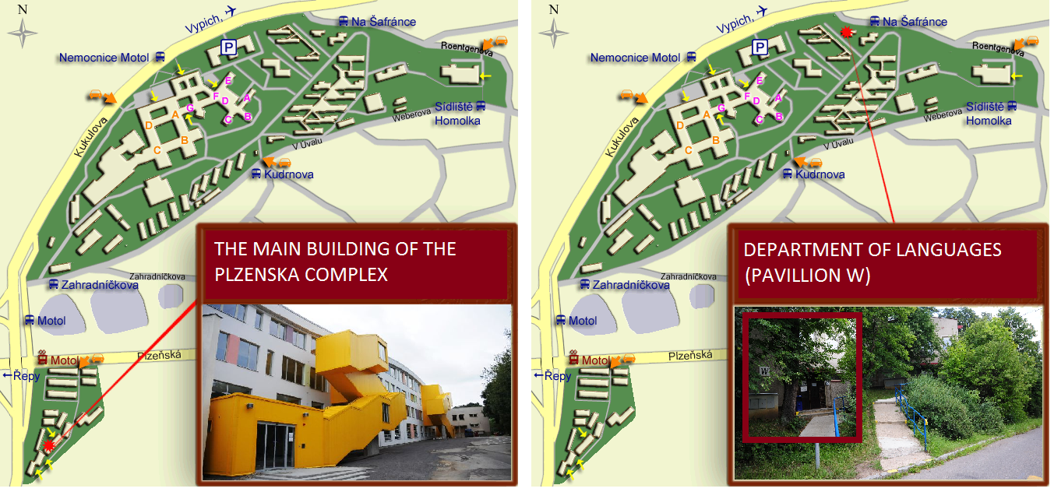

Directions for possible routes to the MOTOL HOSPITAL (and Department of Languages):

* **From Anděl**: take bus 167 straight to Nemocnice Motol OR take tram number 9 to Motol and then walkto the bus stop Motol across the street and take bus 174, 179, 180 or 184 to Nemocnice Motol (one stop)
* **From Kolej Kajetanka or Kolej Komenskeho**: take bus 174 or 180 straight to Nemocnice Motol
* **From any location on the Metro**: take the *green line* to Dejvicka, then take bus 180 straight to   
  Nemocnice Motol OR the *green line* to Hradčanska and then bus 174 to Nemocnice Motol OR   
  take the *yellow line* to Anděl and follow directions above

Directions for possible routes to the PLEŇSKA COMPLEX:

* **From Anděl:** Take tram 9 or 10 to Motol, walk to the complex across the street as shown in the map above and a short walk straight ahead will take you to the main building of the Plzeňska Complex
* **From Nemocnice Motol:** Take bus 174, 179, 180 or 184 Motol (1 stop) and cross the street to get to the tram stop and follow as mentioned above
* **From Kolej Kajetanka or Kolej Komenskeho:** Take bus 174 or 180 straight to Motol and follow as mentioned above

* More details regarding the transport connection to our Faculty are available at <http://www.lf2.cuni.cz/Informace/espojeni.htm> OR directly at the official website of Prague Transit Company at http://www.dpp.cz/en/

* To participate, please **register before the 11.9.2011** though the soon available online application form. More information will be mailed to your personal e-mail account.

* If you have any questions or need advice, feel free to contact Annika Malmgren, the coordinator of the Fresher’s Week 2011, via e-mail [lilla_jag01@hotmail.com](mailto:lilla_jag01@hotmail.com), or Marta Miranda, who participated in Fresher’s Week 2010 and now succesfully made it through her first year of medical school, martocas23@hotmail.com.

* Contacts for your Czech teachers: Mgr. Petra Fabingerová ([petra.fabingerova@lfmotol.cuni.cz](mailto:petra.fabingerova@lfmotol.cuni.cz)), Mgr. Jana Třešňáková ([janatresna@volny.cz](mailto:janatresna@volny.cz)), Mgr.Ivana Kejvalová ([ivana.kejval@seznam.cz](mailto:ivana.kejval@seznam.cz)).